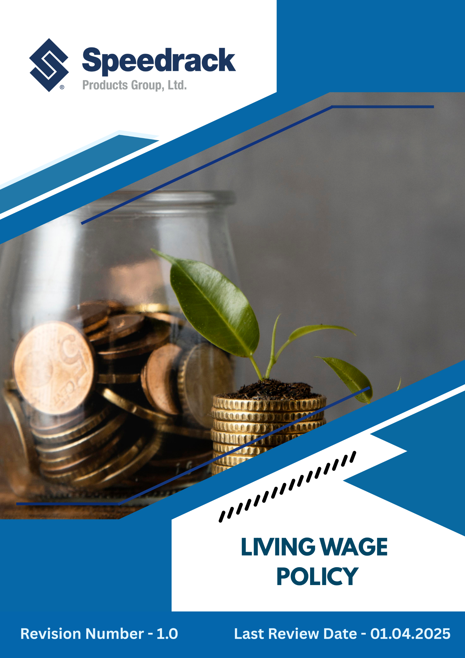
Table of Contents
Introduction 3
Commitment 3
Scope…………………. 3
Our Focus Areas 3
Speedrack’s Approach towards the issues 4
Responsibility of this Policy 5
Reporting 6
Continuous Improvement 6
SDGs Covered by This Policy 7
Review Mechanism 7
Employee Acknowledgement Form 8

Introduction
Speedrack Products Group Ltd. is committed to a fair, safe, and inclusive workplace and to paying a living wage that enables employees to meet basic needs and maintain a decent standard of living. This policy reflects Speedrack’s commitment to ethical labor practices, human rights, sustainability, and employee well-being.

Commitment
Speedrack Products Group Ltd. is committed to ensuring that all employees receive wages that meet or exceed the applicable living standards across their respective regions in the United States, covering essential needs such as housing, healthcare, food, transportation, and education. In full compliance with the U.S. Fair Labor Standards Act (FLSA), applicable federal, state, and local minimum wage laws, and overtime regulations, the Company ensures lawful, fair, and timely compensation. Wages are regularly reviewed and adjusted in line with changes in cost of living, regulatory requirements, and Speedrack’s ethical labor standards to support employee well-being and financial security.

Scope
This policy covers all full-time, part-time, temporary, and contract employees, including those at subsidiaries, operational sites, and third-party contractors, who are required to comply with living wage principles. Executive-level employees may have separate pay structures, but the living wage applies to the broader workforce. Where local laws mandate higher wages, compensation will follow those requirements.
Sr. No | Unit Name | Address
1 | Manufacturing Site | 42 Cole St, Quincy, MI 49082
2 | Manufacturing Site | 3060 S Industrial Dr NW Walker, MI 49544
3 | Corporate Office | 3060 S Industrial Dr NW Walker, MI 49544

Our Focus Areas
- Fair and Responsible Wage Practices: Ensuring fair, transparent, and equitable wage structures that align with credible living wage benchmarks and reflect local cost-of-living realities.
- Living Wage for Contract and Indirect Workers: Extending living wage commitments across the value chain, including service partners, third-party labor, and contract workers.
- Employee Well-Being and Financial Resilience: Promoting financial security through supportive benefits, financial literacy initiatives, and programs that help employees meet essential living needs.
- Transparent Wage Monitoring and Reporting: Establishing structured monitoring and assessment mechanisms to evaluate wage levels, track improvements, and report progress transparently.

Speedrack’s Approach towards the issues
Speedrack is committed to ensuring that every employee earns a wage that supports a decent standard of living. The Company adopts a proactive approach designed to promote financial well-being, transparency, and accountability across all levels of the organization. The following targets have been set in alignment with Speedrack’s 2022 baseline performance data.
Fair Compensation
- Speedrack ensures equal pay for equal work through structured, documented, and management-reviewed annual pay equity assessments.
- The company maintains a transparent wage governance framework, clearly defining wage structures, overtime, incentives, and benefits.
- Living wage principles are embedded into all internal HR and procurement decision-making processes.
- 100% annual pay equity reviews conducted across all departments and locations by 2030.
- Aim to achieve minimum 100% of employees paid at or above verified living wage benchmarks by 2030.
Legal Compliance
- Speedrack maintains full compliance with all applicable local, national, and international labor and wage laws at all times.
- A zero-tolerance approach to wage-related non-compliance is enforced across internal operations and suppliers.
- Regulatory updates are systematically monitored and embedded into internal wage procedures without delay.
- Wage compliance responsibilities are clearly defined within HR, finance, and senior management roles.
- Aim to conduct 100% statutory wage and labor law audits annually across all operational locations by 2030.
- 100% closure of identified wage compliance gaps within 60 days of audit completion by 2030.

Responsibility of this Policy
- Board of Directors / Senior Leadership Team
- Provides strategic direction and integrates living wage commitments into Speedrack’s organizational priorities.
- Allocates resources necessary to enable fair wage practices across all operations.
- Promotes a workplace culture rooted in fairness, transparency, and ethical labor standards.
- Chief Human Resources Officer (CHRO)
- Review living wage policy annually.
- Leads wage benchmarking and analysis using national and international living wage indicators.
- Conducts structured wage reviews and maintains accurate compensation documentation.
- Ensures alignment with local labor laws, global standards, and internal compensation frameworks.
- Review entire policy and communicates policy expectations and updates to employees and internal stakeholders.
- Finance Department
- Supports financial planning and budget allocation for wage-related initiatives.
- Analyzes compensation data and assesses cost impacts associated with wage adjustments.
- Ensures financial sustainability while advancing equitable compensation practices.
- All Employees
- Understand and uphold the principles and expectations of this policy.
- Report wage fairness concerns or related issues through designated grievance channels.
- Provide constructive feedback during wage surveys or employee satisfaction assessments.
- Cooperate with HR and management during wage review processes.
- Participate in training or awareness programs regarding compensation, benefits, and living wage principles.

Reporting
- Speedrack systematically monitors and evaluates wage and labor practices through periodic internal reviews, compensation dashboards, payroll audits, and workforce well-being indicators.
- The People & Compliance Teams prepare an annual summary highlighting key elements such as grievance resolution timelines, participation in wage-related training, pay equity assessments, working conditions evaluations, and employee engagement outcomes.
- Progress, challenges, and improvement initiatives are reported to Executive Management and the Board to enable informed decision-making and ensure accountability.
- Policy developments, achievements, and critical updates are communicated to employees, suppliers, and relevant stakeholders via formal communications, ESG reporting, internal bulletins, and workforce meetings.

Continuous Improvement
Speedrack is committed to continuously strengthening its living wage practices in line with global ethical and labor standards. The Company regularly assesses performance through audits, employee feedback, and external evaluations, and invests in training, technology, and systems to enhance wage administration and workforce well-being. Speedrack collaborates with employees, unions, and supply chain partners to identify opportunities for improvement and proactively address challenges. Corrective and preventive actions are implemented promptly to resolve wage-related non-compliance, close gaps, and protect worker financial security.

SDGs Covered by This Policy
This Environmental Policy supports the following United Nations Sustainable Development Goals (SDGs):
 | 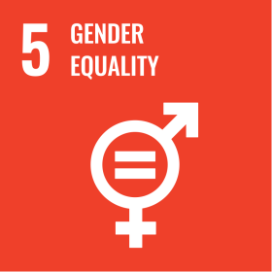 | 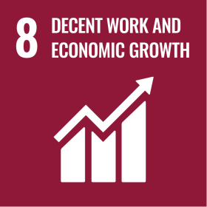 | 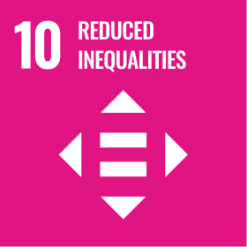

Review Mechanism
The Chief Human Resources Officer (CHRO), with support from Senior Leadership, conducts an annual evaluation or as needed of this policy to monitor progress, identify areas for improvement, and ensure alignment with evolving legal, ethical, and industry standards. Based on review outcomes, wage compliance assessments, emerging global benchmarks, and organizational needs, the policy may be updated or strengthened. Any significant revisions or updates are communicated to employees, contractors, suppliers, and other relevant stakeholders to maintain transparency, clarity, and alignment across the organization.

Effective Date: 01.12.2024
Last Review Date: 01.04.2025 Rev. No. 1.0
Next Review Date: 01.04.2026

Employee Acknowledgement Form
I confirm that I have received, read, and understood Speedrack Products Group Ltd.’s Living Wage Policy.
I recognize my responsibility to uphold fair compensation principles, promote dignity and ethical conduct in the workplace, and report any wage-related concerns or violations promptly and responsibly.
I understand that adherence to this policy is a mandatory requirement of my employment, and non-compliance may lead to appropriate disciplinary action.
By signing below, I agree to support and comply with this policy.

Employee Name: ___________________________________
Department: ________________________________________
Designation: ________________________________________
Signature: ___________________________________________
Date: ______________________________________________

